**PH233 End-semester exam Module C: Controller**

From Modules A and B we have a clear idea of the range of voltages coming from the sensor, and the range of voltages to be driven into the actuator as shown in Fig 1

Fig 1: Progress so far from Modules A + B: we have the plant, now we build the controller

**Module A:** got voltage range expected by Actuator

**Module B:** got voltage range produced by Sensor

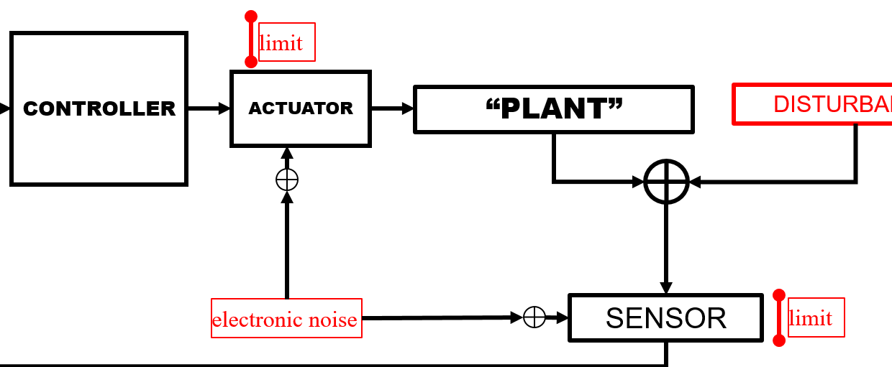

CONTROLLER

In this module, we will build and test the highlighted controller module in Fig 1

Since Vout|sensor and Vin|actuator ranges are known, we are now ready to implement the mathematical feedback equation:

in terms of real voltage signals between opamp based blocks

For this assignment, we simplify the controller by dropping the latter 2 terms and implementing only the proportional term:

Though very simple, controller based on equation 1 has major drawbacks for our breadboard feedback control system:

Vout|controller can be positive or negative depending upon sign of . However, our actuator (LED) requires positive drive voltage (0 – 4V as tested in Module A). Hence Vout|controller → Vin|actuator needs to be positive definite

If we don’t make provision for an offset voltage, consider the case when : , thus turning-off the LED. No light incident on the sensor will increase to maximum pushing to max driving the LED back to full brightness! This cycle continues and the controller will oscillate

Hence, we need to modify the controller output equation by adding an offset

…… **Equation (2)**

Where is generally set to half the range of Vin|actuator.

Use **INVERTING** configuration opamps for both the following questions C.1 and C.2. To keep the two terms in Equation 2 independent, use one opamp to implement and a second opamp to add Voffset

**C.1) P controller 10**

This is simply an inverting opamp gain configuration whose gain corresponds to the proportional constant *KP*

Design and build an inverting gain opamp. Set the gain with a tunable resistor ratio (use a 10kΩ potentiometer in the feedback loop to set the gain)

Test the functioning of your P block and tune its *KP* gain by injecting various DC voltages to make sure it does not saturate the limits of . Assume that this is the worst case error imbalance you expect to see when you close the feedback loop.  
**Circuit design and simulation (LTSpice) 5**

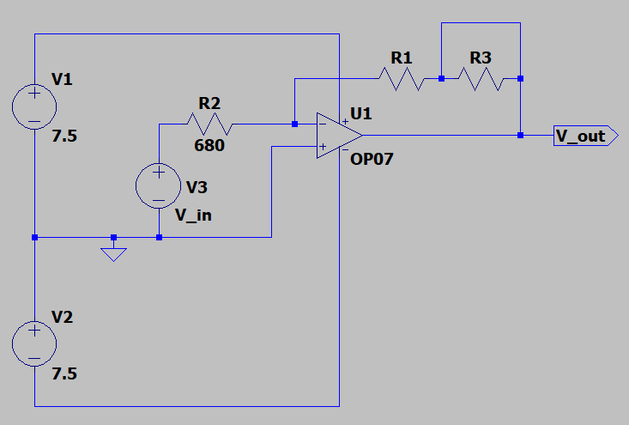

*(NOTE: V1 = V2 = 7.5V due to draining of my battery after prolonged use. Hence, used the same value in the simulation)*

In the above circuit, R1 and R3 correspond to the potentiometer, and Vin ranges from -0.2V to +0.2V.

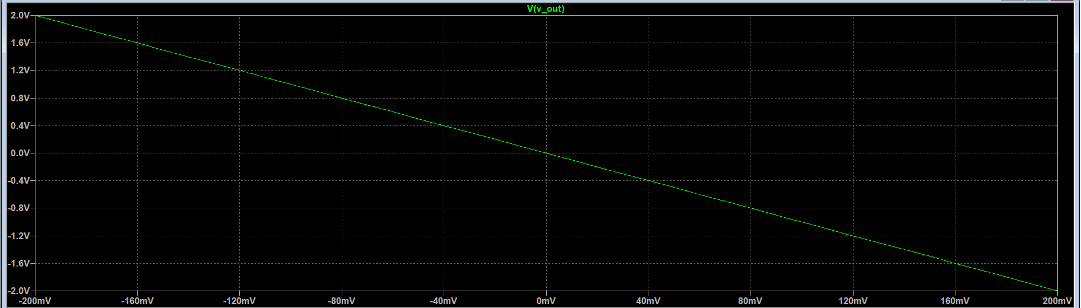

For obtaining the plot above with gain = 10, R2 = 6.8kΩ and R3 = 3.2kΩ. A DC sweep analysis on V3 with range -0.2V to +0.2V generates the above plot.

Photos of built-up circuit tested with worst case DC input voltages of –0.2V and +0.2V and corresponding output voltages at *KP = 10* (measure with DMM) **5**

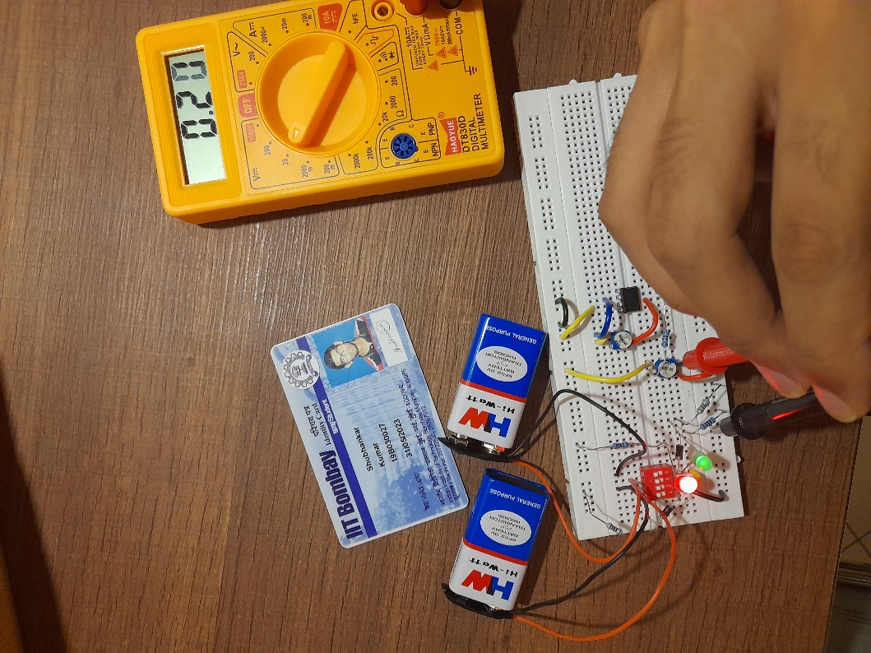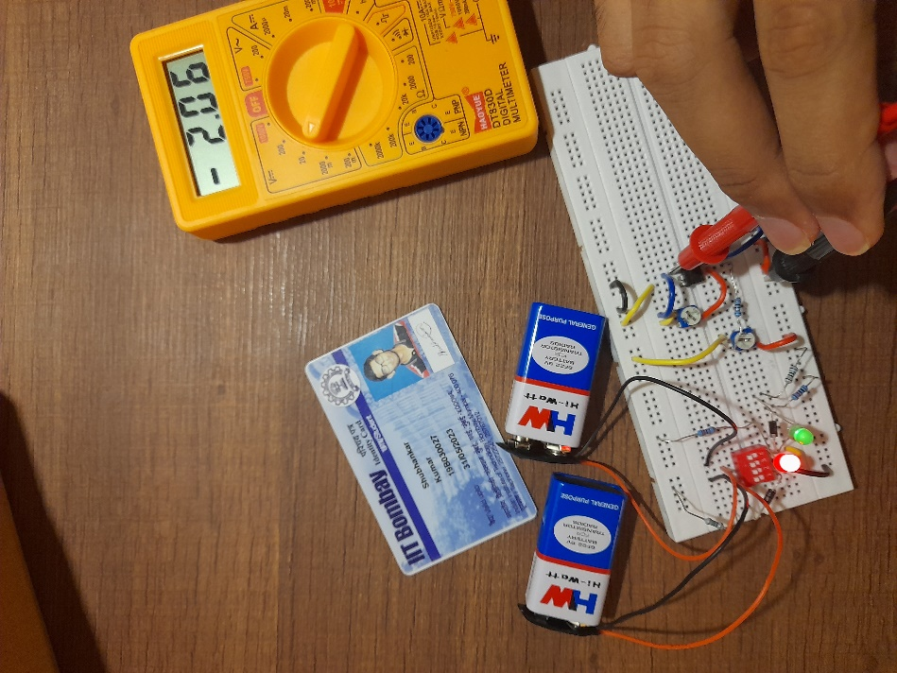

**VIN = +0.2V VOUT = -2.06V**

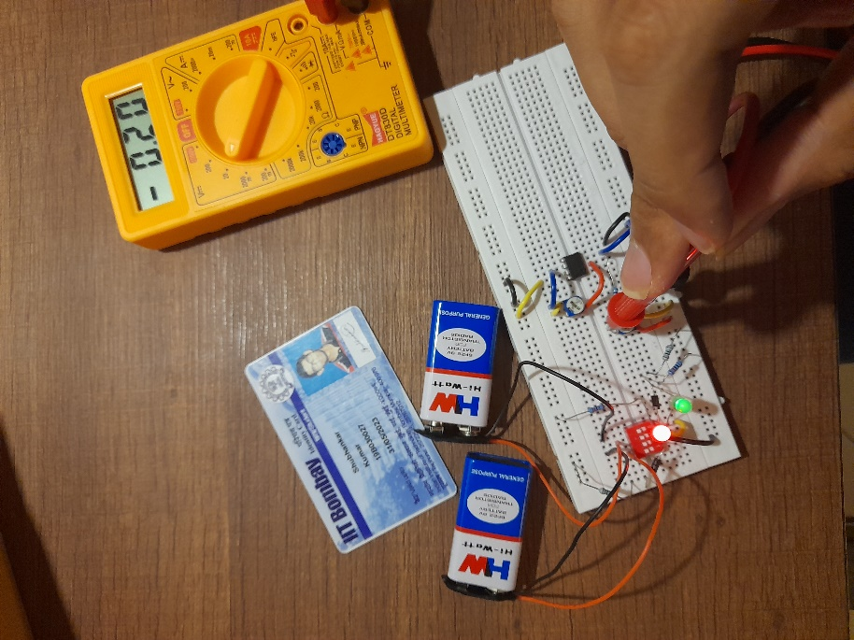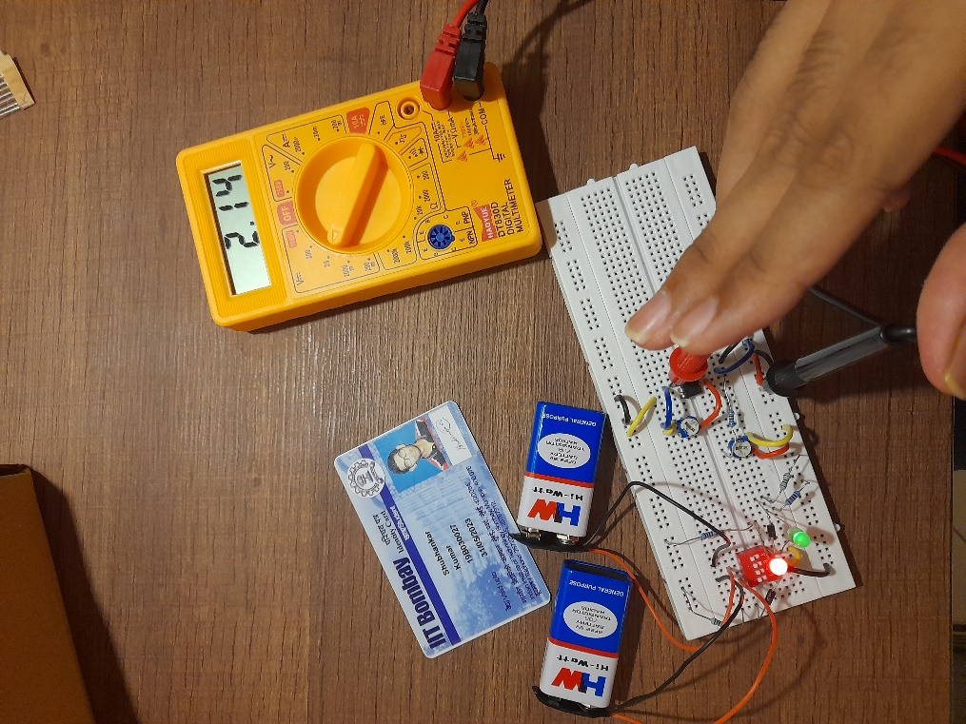

**VIN = -0.2V VOUT = 2.14V**

**C.2) Offset to be added to P control 10**

The keyword here is that you need a **summing** amplifier. is summed with an adjustable DC voltage.

Notice that the gain KP in the feedback controller (Equation 1) is positive by definition.

**Due to the TWO inverting stages used in the above questions C.1 and C.2, the net gain of your P controller will be positive** Each opamp is setup up for inverting operation. So (-1)×(-1) the net gain of the controller comes out positive.   
The advantage of using two opamps is that it allows you to keep the two terms in Eqn 2 independent

**LTSpice Circuit** design and simulation adding two DC voltage levels **5**

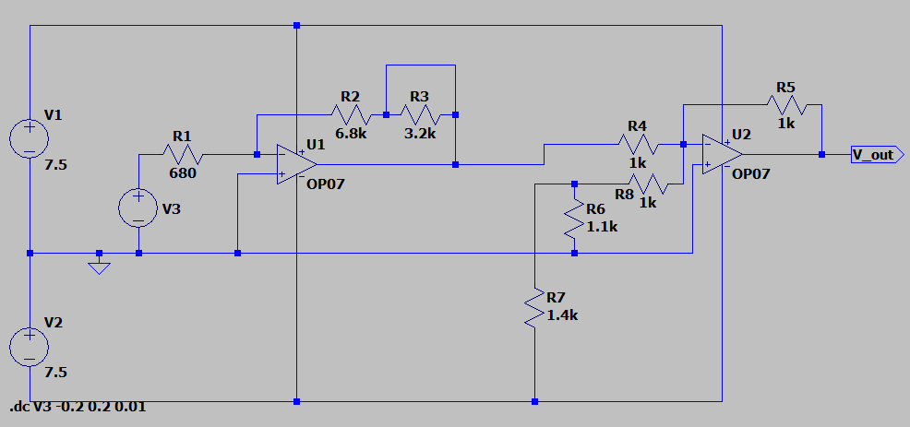

In the above circuit, R6 and R7 are chosen such that Vjunction = -2V

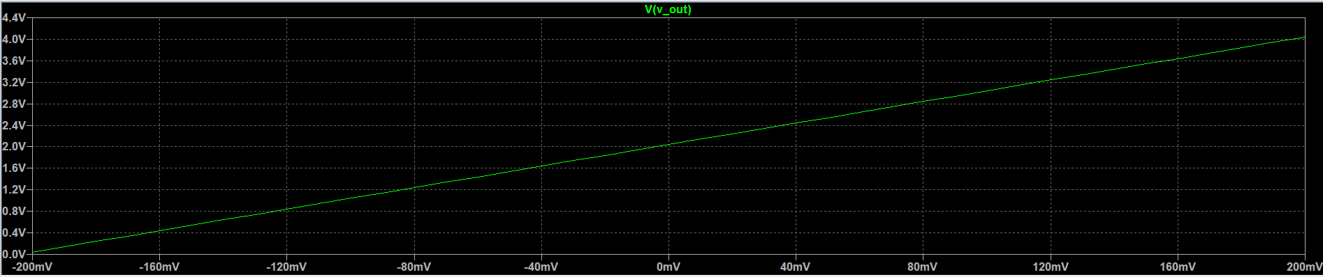

We see that for VIN = -0.2V, the output from the first op amp will be +2V. This is added with Vadjust = -2V, giving 0V as the output from the second op amp. In a similar way, we get +4V as the final output when VIN = +0.2V

**Circuit demo:**  Connect the summing amplifier on your breadboard. Measure with DMM a DC voltage +2V being summed to each of the KP×(±0.2V) cases checked in question C.1 **5**

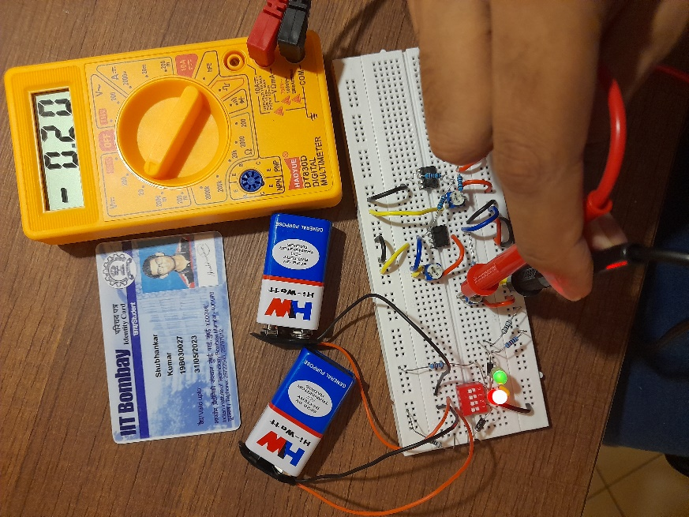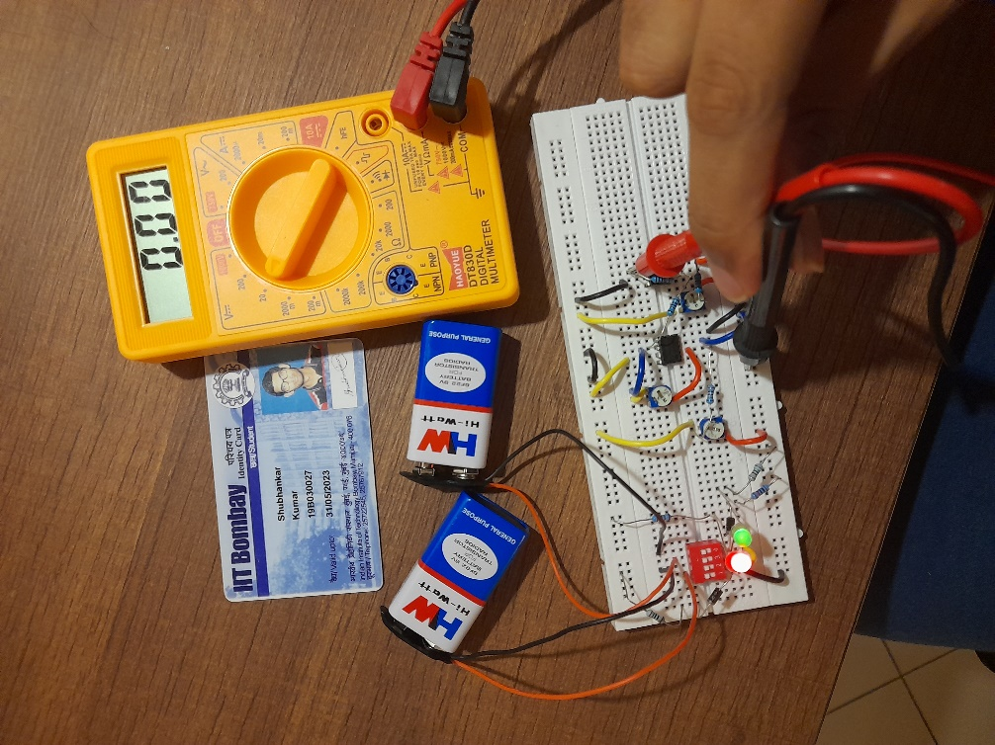

**VIN = -0.2V VOUT = 0V**

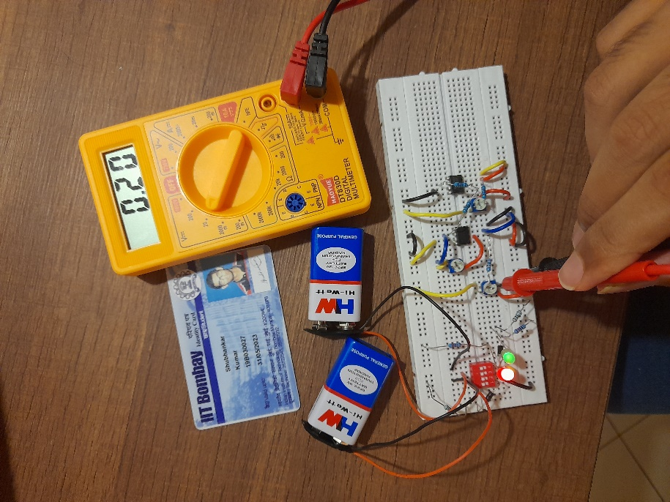

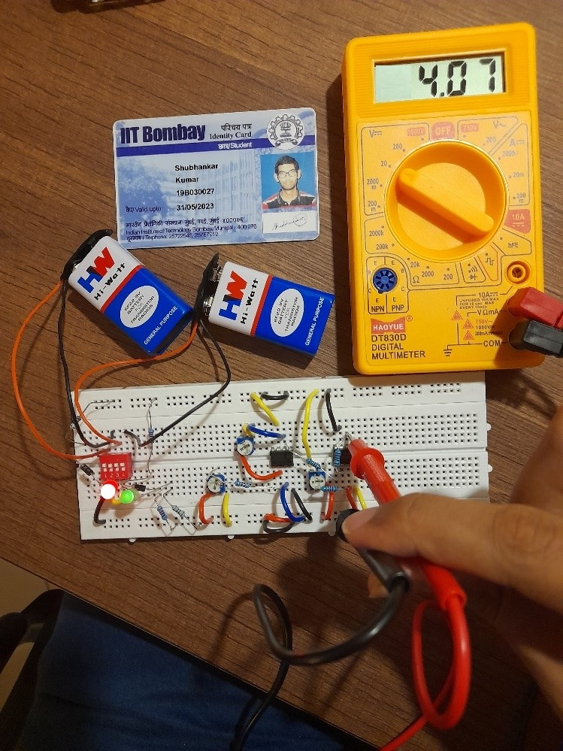

**VIN = +0.2V VOUT = 4.07V**